|  |
| --- |
| department of computer science |
| RFA: User Manual |
| Capstone Project |
| prepared by |
| **Lauren Antrobus**  *antlau001@myuct.ac.za*  **Merada Richter**  *rchmer002@myuct.ac.za*  for  **Sonia Berman**  **(p.p. help2read)**  on |
| **22 September 2013** |

|  |
| --- |
|  |

Table of Contents

Welcome 2

Starting Up 2

Fill-a-word Game 3

Comprehension Game 4

Using the Word Tray 5

Using the Dictionary 6

That’s all Folks! 8

# Welcome

Welcome to *Flua* – a reading fluency aid designed to encourage and improve basic reading abilities through fun games. *Flua* is designed for children whose English reading abilities are not very advanced and require practice. *Flua* is very easy and intuitive to use – but just in case you need some guidance, this manual is here to help.

# Starting Up

When Flua is started, the following main screen will appear. Depending on what activity you would like to do, choose the *New Fill-a-Word game* or the *New Comprehension game* by clicking on the appropriate button.

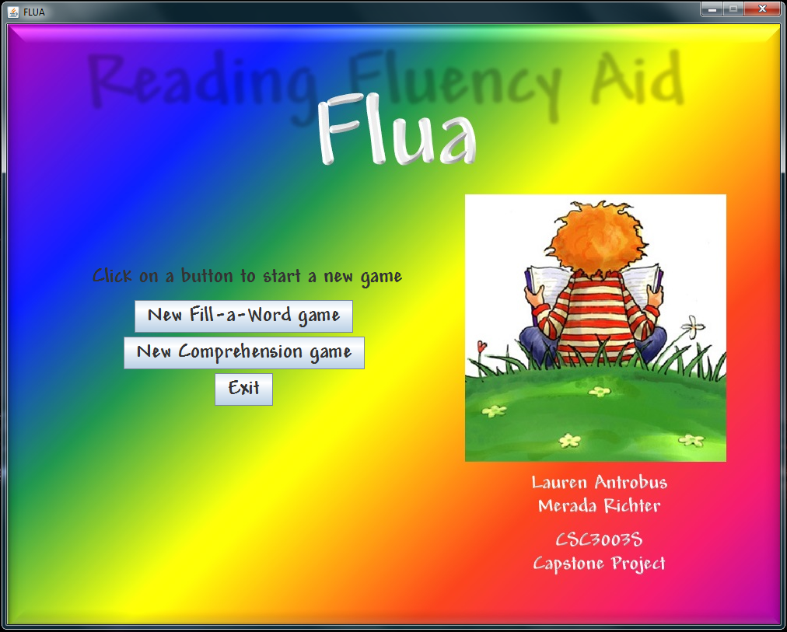

**Diagram 1**

# Fill-a-word Game

When playing the *Fill-a-word* game will display a picture of a fun and busy scene. Below the picture, observations about the scene will be displayed – with a word missing. Users should complete the sentence by filling the missing word in to the text field below. Answers can be saved by clicking the *Accept* button, and users can switch between questions by using the arrow buttons. Helpful word suggestions will be available on the word tray on the right of the screen and definitions can be searched by looking them up in the dictionary (see the appropriate sections below for more detail).

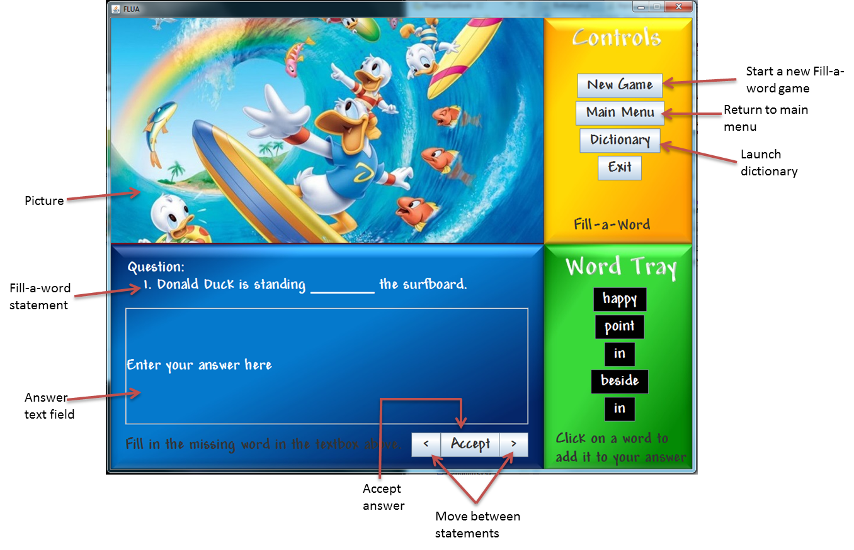

**Diagram 2**

# Comprehension Game

The *Comprehension* game allows users to read a story and create their own comprehension questions about a story. The story will be displayed on the pages of a book at the top of the window, with a text field below where users can enter their questions. Once happy with your question, click the Accept button to save it, and use the arrow buttons to move between your different questions.

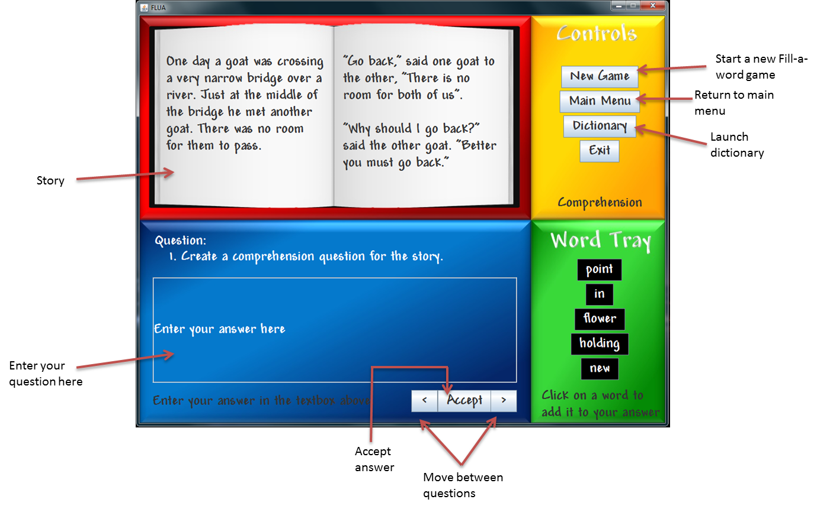

**Diagram 3**

# Using the Word Tray

The word tray is available in both the *Fill-a-word* and *Comprehension* games and is placed in the green tile on the right hand side of the window. The word tray suggests words to the user, which they might find useful in either of the activities. Users can make use of these words by clicking on the appropriate word, which will then be inserted into the text field on the left of the word tray (see diagram 4 below.)

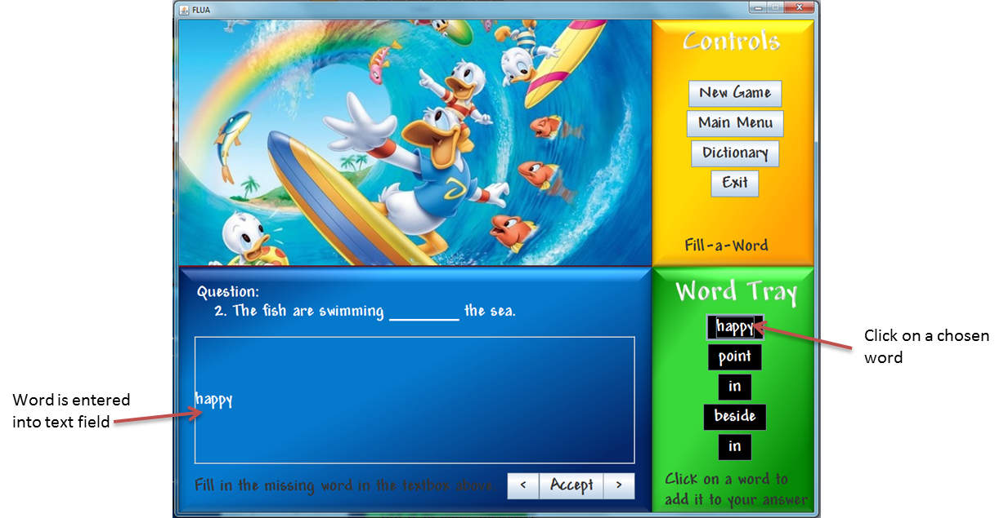

**Diagram 4**

# Using the Dictionary

Flua provides an editable dictionary where users can look up words they might not understand. This can be launched by clicking on the *Dictionary* button on either of the game screens.

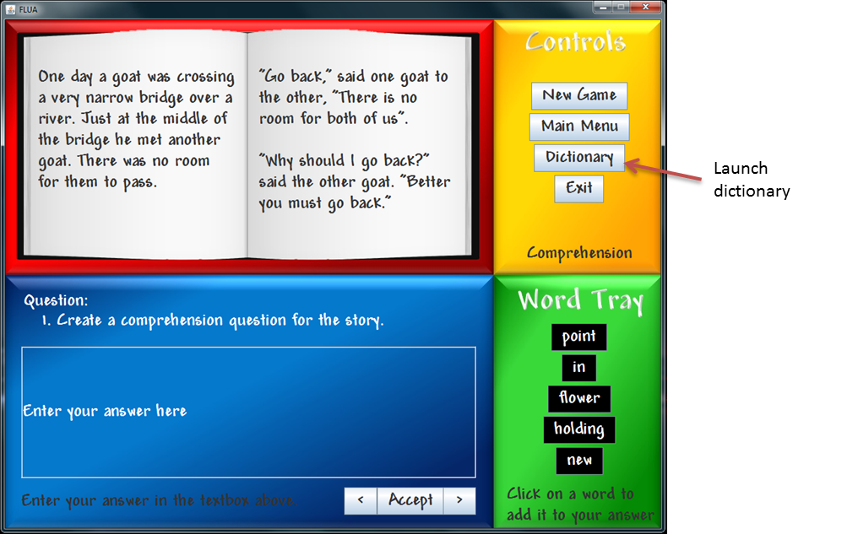

**Diagram 5**

An blank Dictionary screen will be launched, as shown in diagram 6.

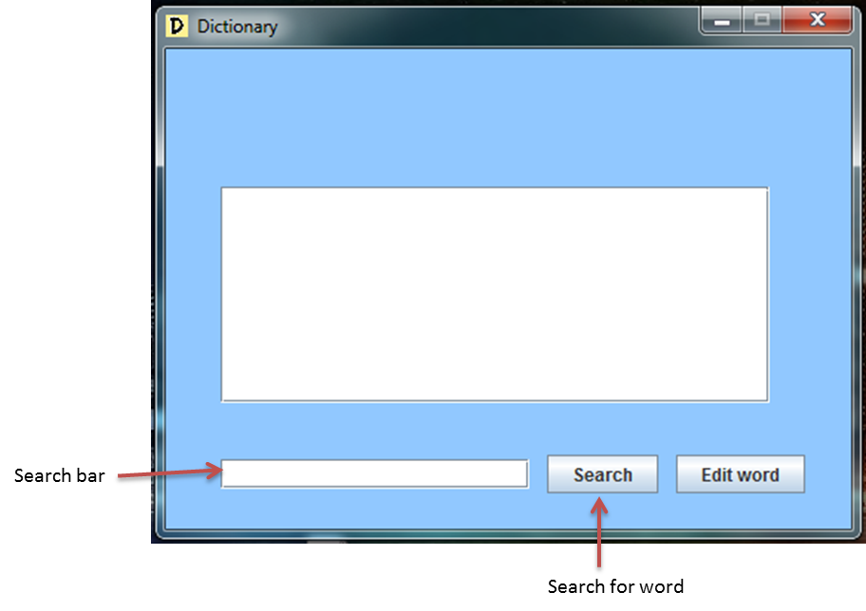

**Diagram 6**

To search for a word, enter the word into the search bar and click on the search button. If the word is found in the dictionary, a screen similar to that shown in diagram 7 will appear – showing the word and its definition.

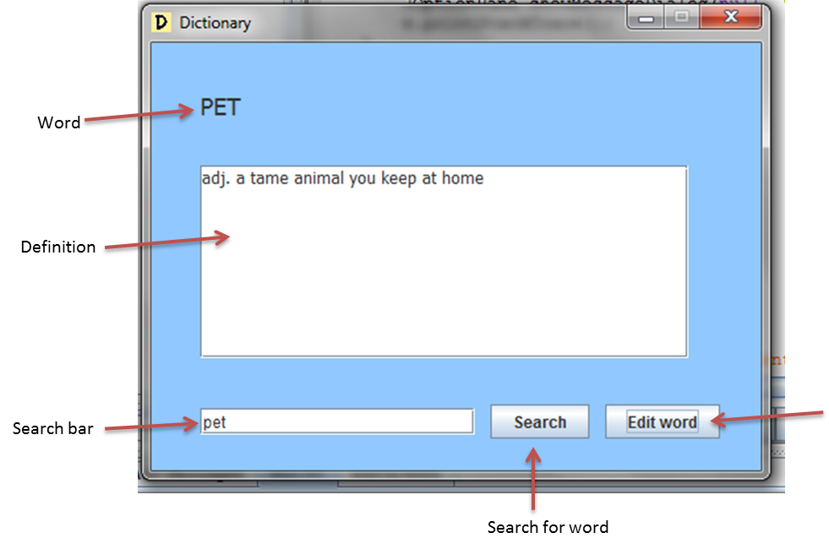

**Diagram 7**

If the word is not found in the dictionary, the user will be asked whether they would like to add the word to the dictionary or not, as in diagram 8. This way you can expand and customize your dictionary to your preferences.

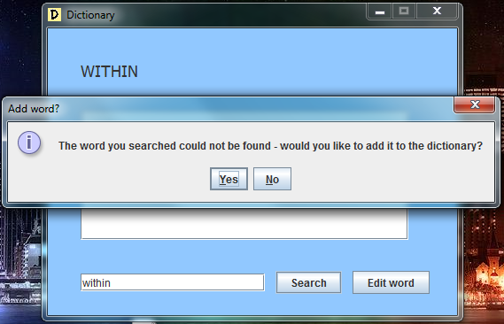

**Diagram 8**

Users are also able to edit word definitions, which will be saved permanently to the dictionary. This can be done by clicking on the *Edit Word* button, which will turn the definition text area a yellow colour and enable the user to edit the definition – as depicted in diagram 9.

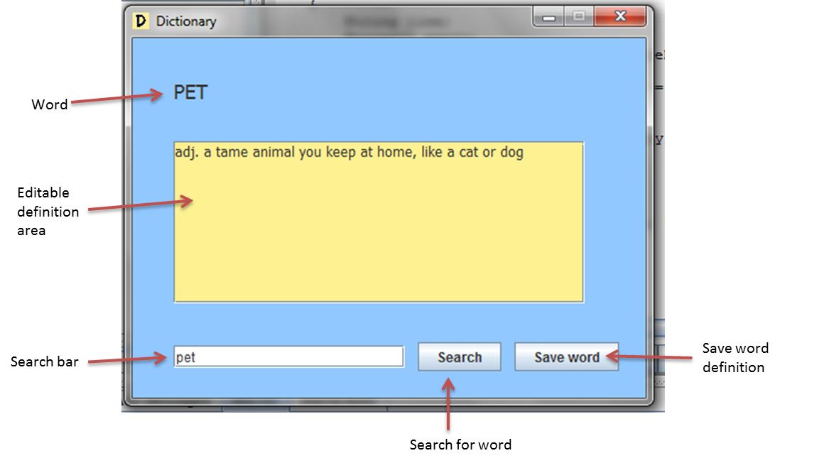

**Diagram 9**

# That’s all Folks!

We hope that these hints have cleared any confusion in your mind about using *Flua* – so now it’s time to go and enjoy it!